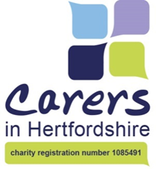
Brief for Focus Group Leaders
Healthy Hubs
Many thanks for agreeing to help us with this group work.
The format of the event is:
- Registration, coffee and information tables
- Introductions from Professionals
- Focus group work / Care Planning / Medical Checks / Fitness checks
- Social time / chance to speak 1:1
- Closing comments / thanks

- We have allowed 40 minutes for focus group discussions

During this period people may come and go from the group to visit the Carer Support Advisor or Medical Staff who may be in separate rooms. There will be some other organisations present on the day (e.g. Pharmacist, Sports Centre)

- Encourage your group to work in pairs and use Post-it notes

Record ideas so we don’t lose feedback even if they doesn’t get to speak.

- Remind them this is a new approach at working together with GP Surgeries

- Remind them of the rules, copy on the table

If carers bring up a lot of personal issues say that they can be discussed 1:1 after 12 noon when the groups finish. Close down personal comments / queries about staff and individual surgeries.
These are the questions to discuss:
- What do you like about using the GP Surgery?
- Do you have suggestions for improving the service for carers from GP Surgeries?
- If you could wave a magic wand what would help you most as a carer?

- We will ask the groups to provide feedback on the 3 points.
- Ask carers to complete a brief evaluation form before they leave the table.

